TITLE (TNR, 14, CENTER, UPPERCASE)

First A. Author*¹, Second B. Author2 and Third C. Author3

¹Authors’ Department, Institute, City, COUNTRY.
(E-mail: firstauthorsname@abcd.wxyz)
²Author’s Department, Institute, City, COUNTRY.
(Email: secondauthorsname@abcd.wxyz)
³Author’s Department, Institute, City, COUNTRY.
(E-mail: thirdauthorsname@abcd.wxyz)

Abstract (TNR, 12, single spacing, justify, Italic)

The abstract should not more than 250 words each. The abstract should not only indicate the subject and scope of the paper, but also summarize the author’s conclusion. Structured abstract must be a brief, comprehensive summary of the contents of the article. It allows readers to survey the contents of an article quickly. An Abstract summarizes the major aspects of a paper. It should succinctly summarize the purpose of the paper, the methods used, the major results, and conclusions.

Keywords
Keyword 1, Keyword 2, Keyword 3 (Min 3 key words & Max 5 Key words) (TNR, 12, Capitalize each word, Italic)

Introduction

This format is to be used for submissions that are published in the proceeding of the ISHT 2018. We wish to give this proceeding a consistent, high-quality appearance. We therefore ask that authors follow some simple guidelines. In essence, you should format your paper exactly like this document. The easiest way to do this is simply to download a template from the conference web site and replace the content with your own material.

The extended abstract should be written in MS Word format in single-spaced in 12-point Times New Roman. Do not indent the text paragraphs. Please briefly explain these:

Purpose of the study
Design and methodology
Analysis and findings
Discussion
Conclusion

Please observe Figure 1 and Table 1 to include figures and tables in the abstract, respectively.

Authors are requested to submit the Abstracts (maximum of 250 words the length) in electronic form (MS-Word) via our Online Submission.

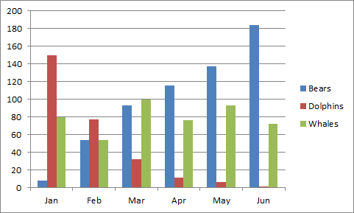

Figure 1. Example of figure for the extended abstract.

A table should be inserted like the one below and referred in the text.

Table 1. Example of table for the extended abstract
Contents of Table

References
(American Psychologist Association (APA) Style 7th Edition)
The minimum are 10 references.

Margins for the article is: top 2 cm, bottom 2.2cm, left & right 2cm

